Name: R Sandhiya
Reg No: 192511132
EXP NO 1:
Date: 01/08/2026
CREATE A SIMPLE CLOUD SOFTWARE APPLICATION AND PROVIDE IT AS A SERVICE USING ANY CLOUD SERVICE PROVIDER TO DEMONSTRATE SOFTWARE AS A SERVICE (SAAS).
AIM:
To create a simple cloud software application and provide it as a service using any cloud service provider to demonstrate software as a service (SaaS).
PROCEDURE:
STEP1: GOTO ZOHO.COM
STEP 2: LOGIN TO THE ZOHO.COM
STEP 3: SELECT ONE APPLICATION
STEP 4: ENTER APPLICATION NAME
STEP 5: CREATED NEW APPLICATION
STEP 6: SELECT ONE FORM
STEP 7: THE SOFTWARE HASE BEEN CREATED

IMPLEMENTATION
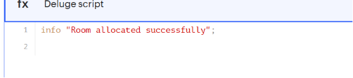

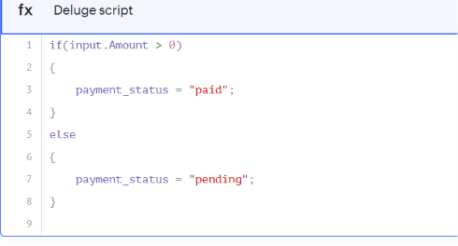

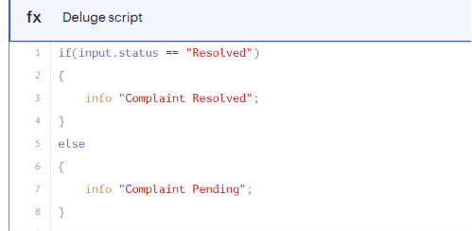

Output
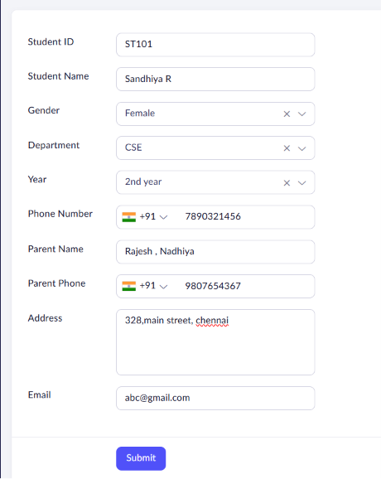
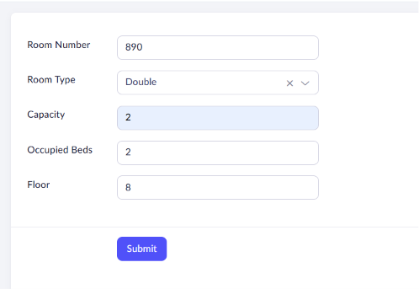
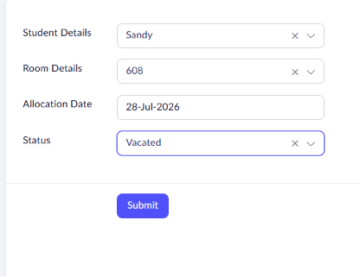
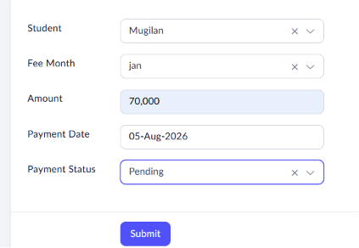


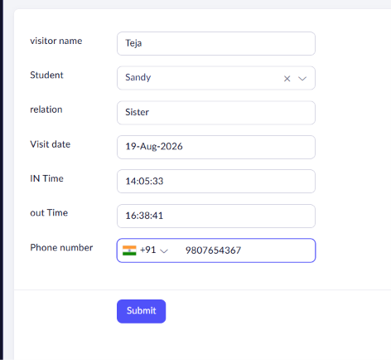
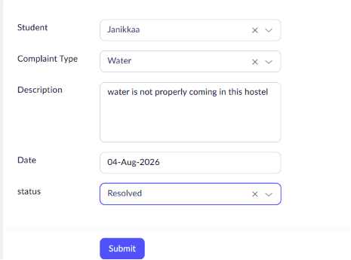
Result
The Hostel Management System was successfully developed in Zoho Creator with modules for student registration, room allocation, fee collection, visitor management, and complaint management. The application automates basic tasks through workflows and provides efficient hostel administration with organized records and reports.

